Task 1:
Avl insertion Algorithm

AVL Insertion Algorithm
1. Create a Node:a
2. Check if Tree is Empty:
3. If the Tree is Not Empty:
Perform Binary Search Tree (BST) insertion:
If key < current node’s key → go to the left subtree.
If key > current node’s key → go to the right subtree.
Recursively insert in the correct position.
4. Update Height:
After insertion, update the height of the current node:
5. Calculate Balance Factor:
o Balance Factor = height of left subtree − height of right subtree
6. Check for Imbalance:
7. Apply Rotations:
8. Repeat Step 4–7 up the recursion stack

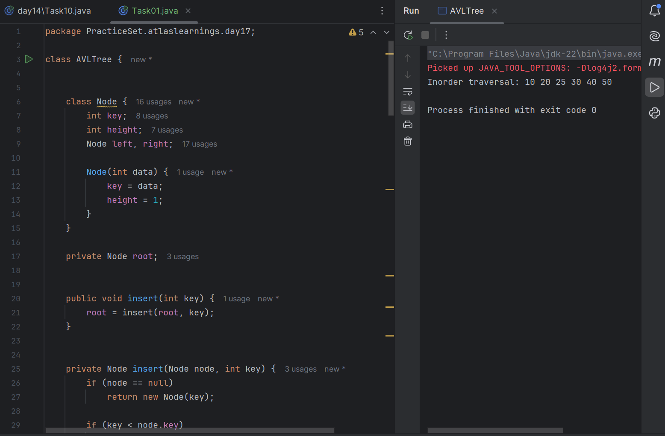
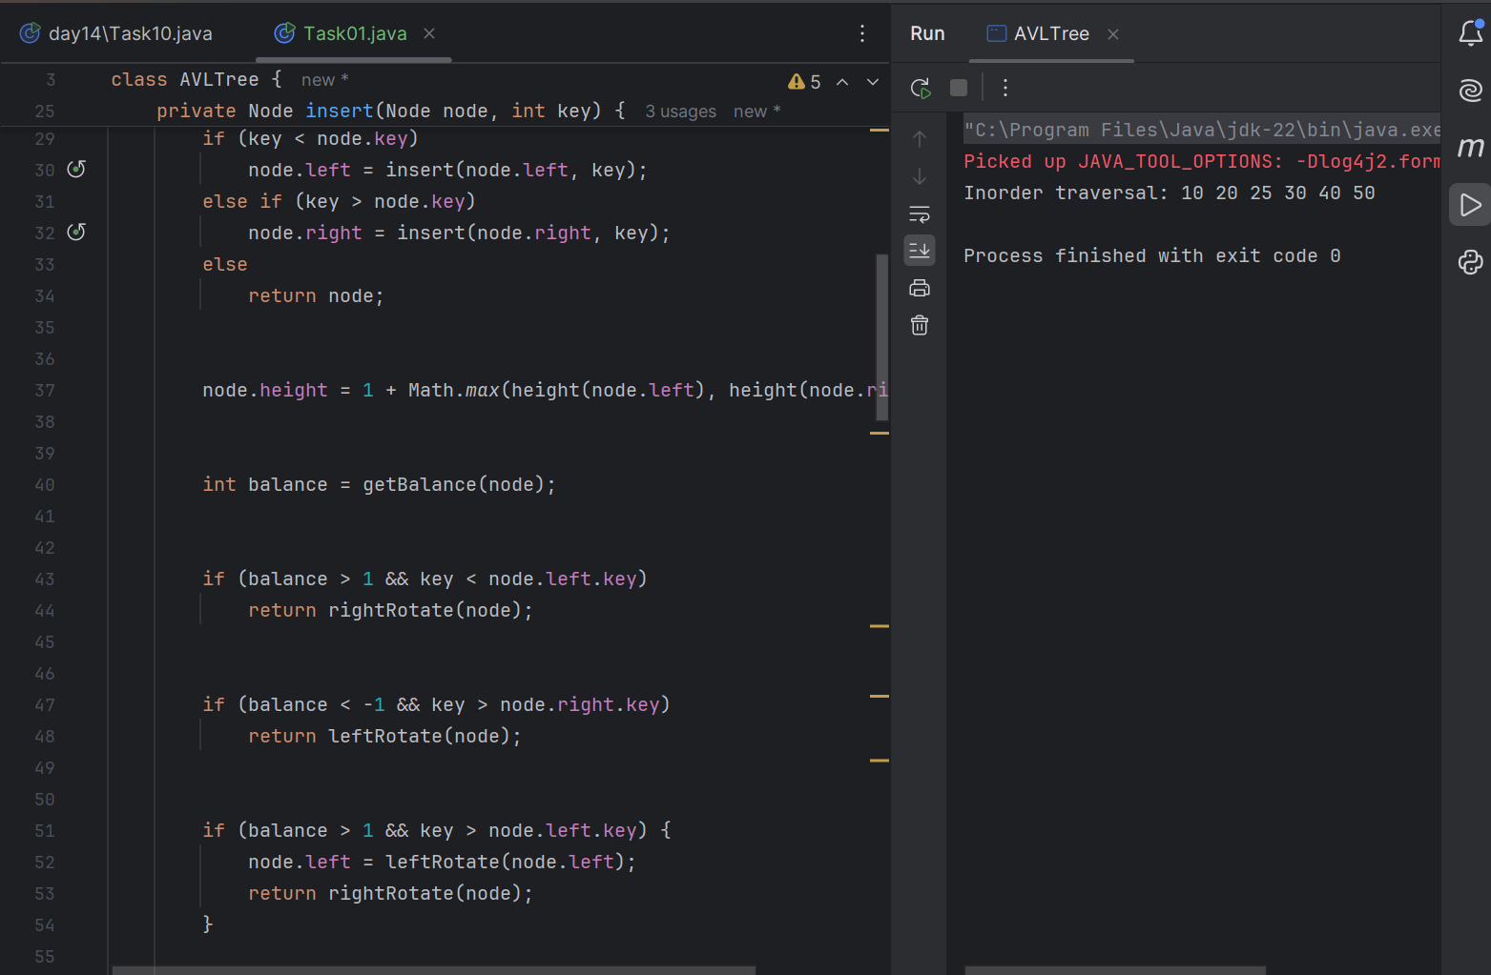
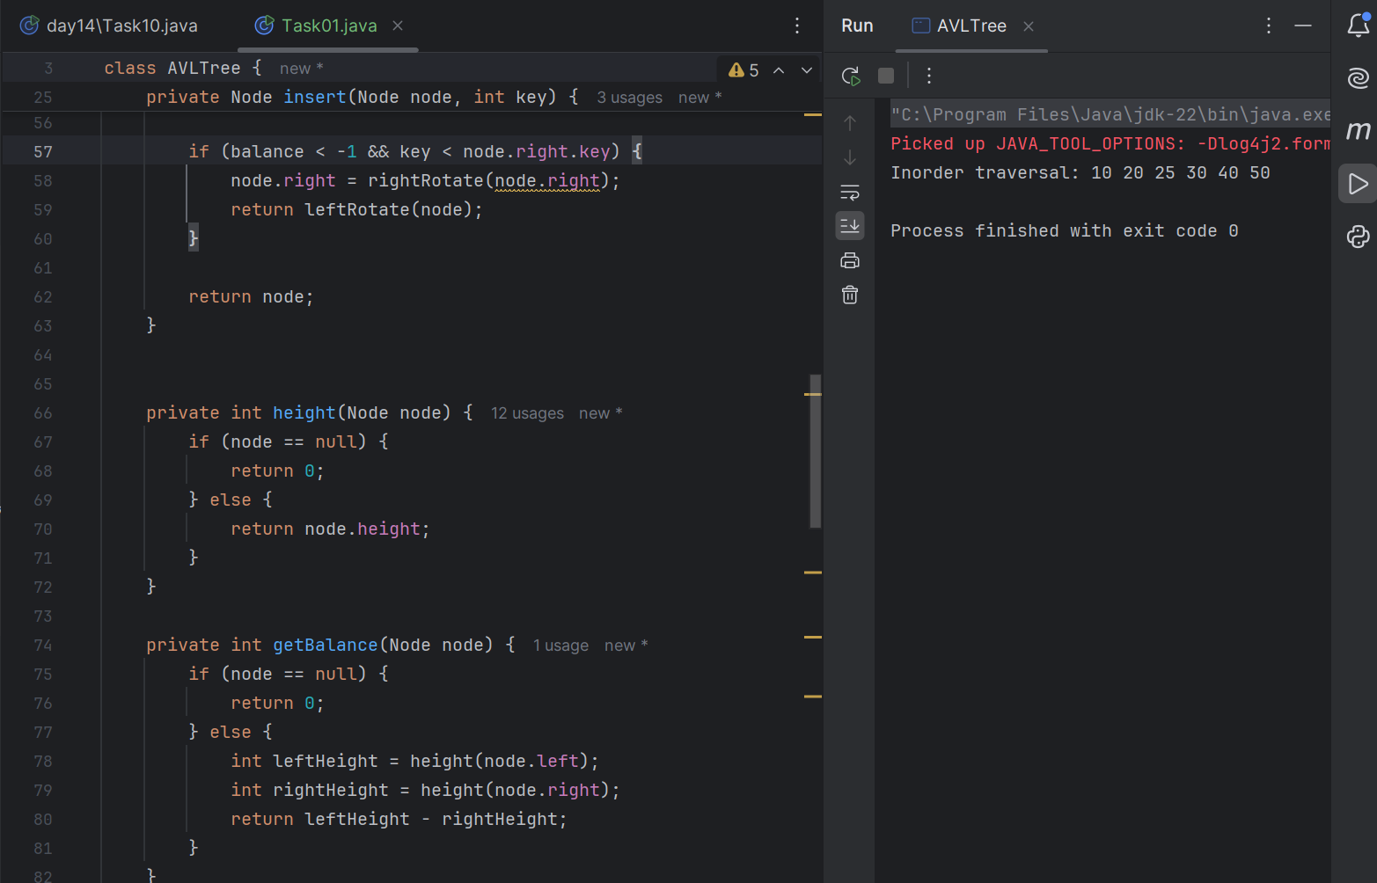
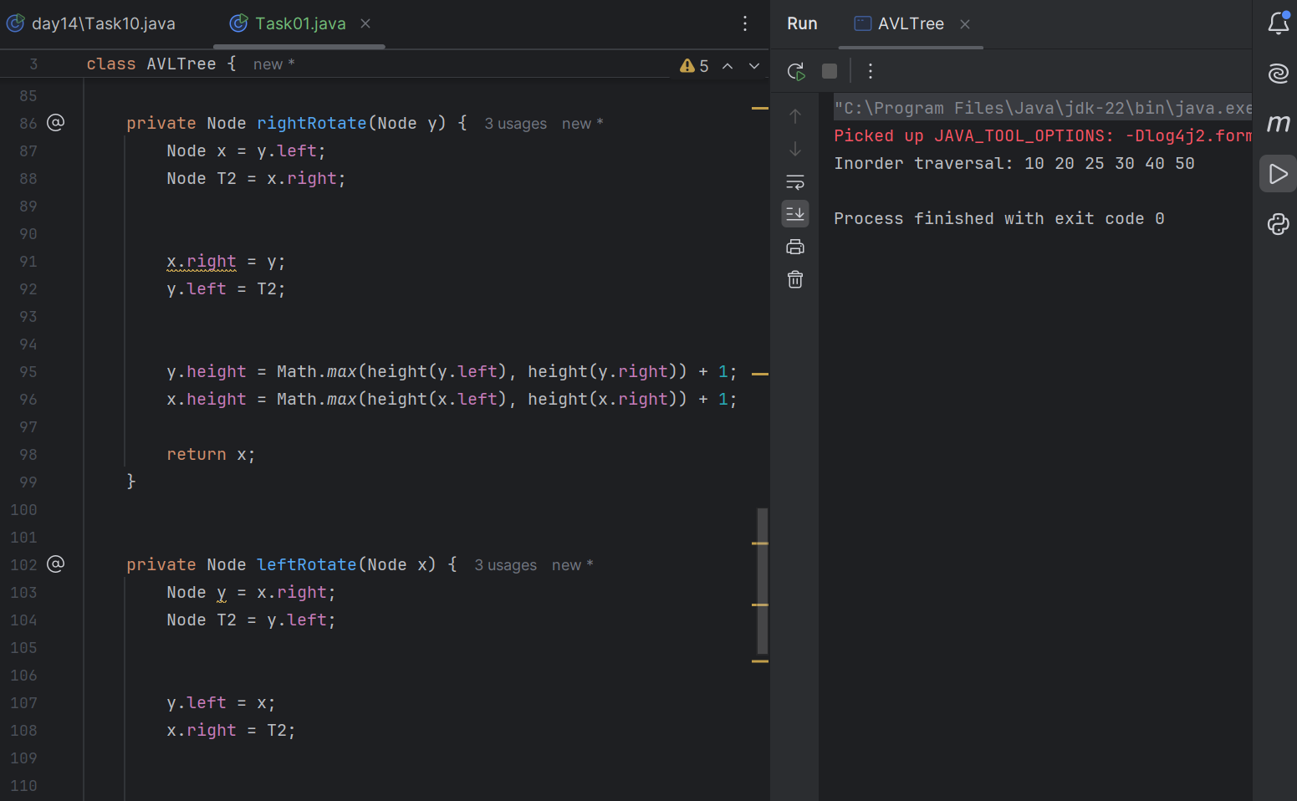
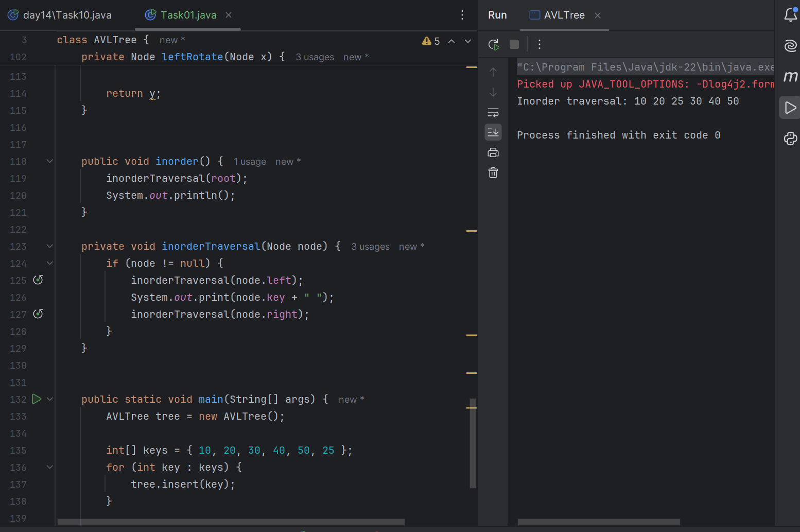

Task 02
